For Immediate Release
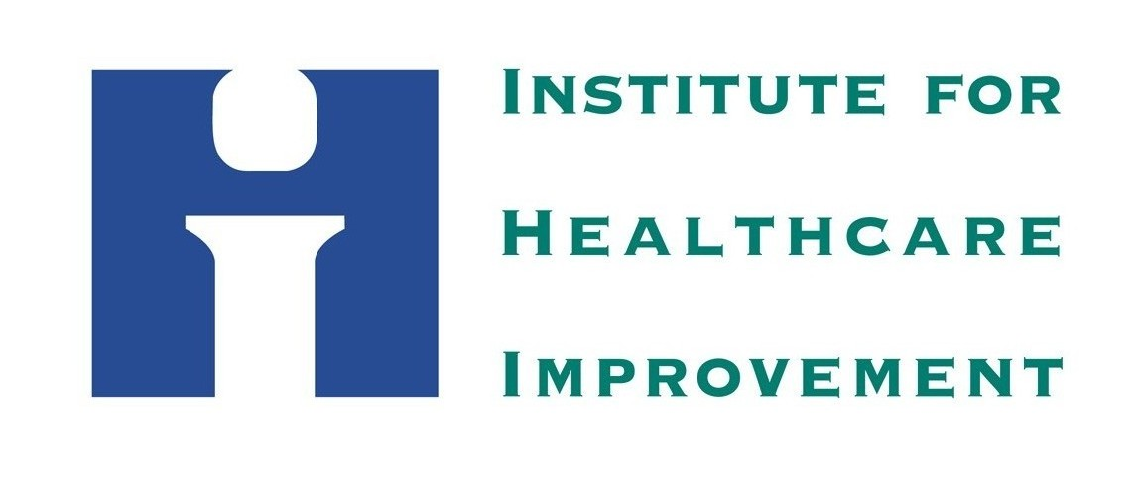
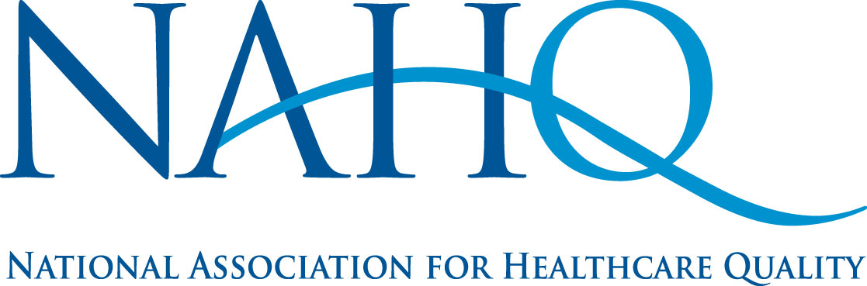

News Release
IHI Contact: Sandy George, CXO Communication
617.413.6126
NAHQ Contact: Maggie Patterson
847.375.4782
mpatterson@nahq.org

IHI, Midas+ and NAHQ Collaborate to Award
First Dr. Heller Memorial Scholarship

Glenview, IL—November 2012— The Institute for Healthcare Improvement (IHI), Midas+ Solutions, and the National Association for Healthcare Quality (NAHQ) are pleased to announce that the Inaugural 2012 Dr. Heller Memorial Scholarship has been awarded to Carolyn Stramecki, MHSA, CPHQ.

The Scholarship, available to a NAHQ member or Midas+ client, requires the applicant to be involved in or have recently completed a major quality improvement project for their facility or organization. This project must reflect what the applicant has learned as a result of taking an IHI Open School course through the Dr. Heller Memorial.

This year’s recipient, Carolyn Stramecki, MHSA, CPHQ, is a NAHQ member and worked as a Performance Improvement Specialist at Sparrow Hospital in Lansing, MI. Based on the IHI Open School course QI 104: “Putting It All Together – How Quality Improvement Works in Real Health Settings”, Carolyn’s submission focused on Michigan’s “Physician Orders for Scope of Treatment (POST) Pilot Program,” a program based on Oregon’s “Physician Orders for Life-Sustaining Treatment (POLST) paradigm addressing public concern that patients’ end-of-life medical treatment wishes were not known or honored.¹

The project identified three communities in Michigan that had experience with the Oregon model, each using its own version of the POLST form. Additionally, they lacked a protocol and training program for Emergency Medical Services (EMS). The project aims to implement the EMS protocol in the pilot communities and test the POST form for statewide spread.

Carolyn, as recipient, will present her poster at the IHI National Forum on Quality Improvement in Health Care, December 9-12, 2012, in Orlando, FL and NAHQ’s 38th Annual Conference in Louisville, KY, October 6-9, 2013.

Note: As a result of Carolyn’s work on the POST Project, she is now Project Director for the Michigan Coalition for Honoring Healthcare Choices.

The Dr. Heller Memorial Scholarship was established in 2012 in joint collaboration with Midas+, IHI and NAHQ. While honoring the memory of Christopher Jonas Heller, MD - a distinguished physician and surgeon with a vision for quality improvement, the intent of the scholarship is to recognize an individual’s contribution to improvements in healthcare quality. Through this scholarship, Dr. Heller’s drive for improving patient care through quality and performance improvement initiatives lives on with those who share his passion.

Founded as MIDS, Inc. in 1987, Midas+ established itself by pioneering an integrated system supporting patient care and outcomes management. Today, Midas+ Solutions provides over 1,500 hospitals and healthcare systems with exceptional solutions supporting safe and effective care to patients in the hospital and community. Specializing in strategic performance management, Midas+ is dedicated to providing hospitals with complete, integrated solutions focused on improving staff workflow efficiency and patient throughput, enhancing patient safety, and increasing hospital profitability.
The Institute for Healthcare Improvement (www.ihi.org) is an independent not-for-profit organization that works with healthcare providers and leaders throughout the world to achieve safe and effective healthcare. IHI focuses on motivating and building the will for change, identifying and testing new models of care in partnership with both patients and healthcare professionals, and ensuring the broadest possible adoption of best practices and effective innovations. Based in Cambridge, Massachusetts, IHI mobilizes teams, organizations, and increasingly nations, through its staff of more than 100 people and partnerships with hundreds of faculty around the world.
Founded in 1976, the National Association for Healthcare Quality (NAHQ) currently has more than 10,000 quality and patient safety professionals working in healthcare settings both nationally and internationally. These professionals drive the delivery of vital data for effective decision making in healthcare systems by combining technology with their unique expertise in quality management. For more information about NAHQ, visit www.nahq.org.

^{1 http://www.ohsu.edu/polst}

